Cover the following video in a Bored Panda-style article: <https://www.tiktok.com/@_itserikav/video/6926931411312135430>

Write a text on the given topic that's at least 2,000 characters long. Use relevant information from other sources to contextualize and enrich the article (credit/hyperlink those sources).

(Chop up the text and place it where indicated.)

Write explanatory headings next to the pictures where indicated. They should provide the basics of the story. (Even those who don't read the text should get a rough idea of what the article is about from the headings alone.)

At the end of the text, write 5 suggestions for the title of the article (each version must be worded differently).

The way parents choose to discipline their children can greatly impact their development and relationships. There are two common approaches to discipline - natural consequences and punishment. Understanding the differences between these two approaches can help parents make informed decisions about how to best support their children.

# **Parenting discipline differences: Punishment and Natural Consequence**

Natural consequences refer to the natural outcomes that result from a child's actions. For example, if a child forgets to bring their lunch to school, the natural consequence may be that they go hungry. This approach emphasizes the importance of teaching children responsibility and making better choices upon reflection, rather than out of fear of punishment. By experiencing the consequences of their actions, children can learn to think critically about their behavior and make informed decisions in the future.

In contrast, punishment refers to actions taken by the parent to correct a child's behavior. Punishment can include physical or emotional actions such as spanking, time-out, or grounding. This approach focuses on control and obedience and can sometimes be unrelated to the problem at hand. For example, if a child throws their ice cream on the ground, a parent may punish them by taking away their Ipad or video games. This type of punishment lacks intention and does not directly tie to the event, making it less effective in helping the child understand the relationship between their actions and consequences. One of the main differences between natural consequences and punishment is the message they send to children.



# **“Allow children to learn from mistakes and develop problem solving skills”**

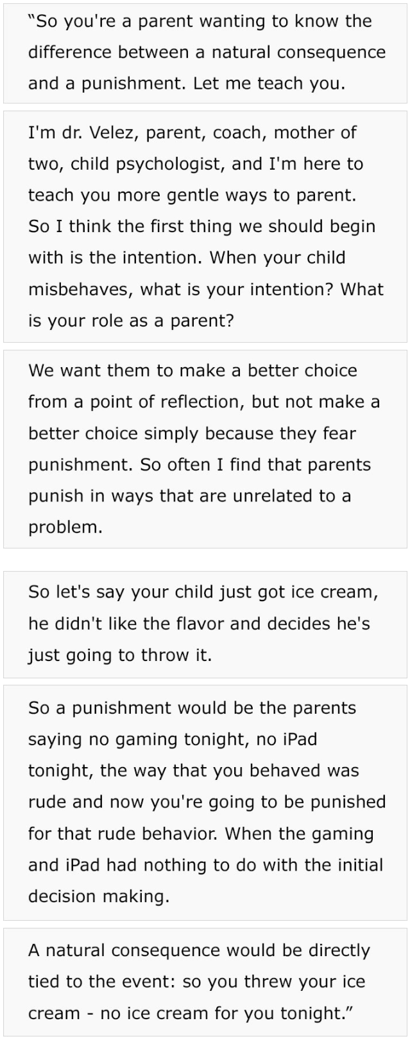

Natural consequences promote reflection and encourage children to take responsibility for their actions. On the other hand, punishment can create fear and resentment in children, leading to a breakdown in the parent-child relationship. Furthermore, punishment can foster a sense of helplessness in children, as they may feel that they have no control over the consequences of their actions.

Another difference is that natural consequences allow children to learn from their mistakes and develop problem-solving skills. When a child experiences a natural consequence that directly ties to the event, such as not having ice cream for the night after throwing their ice cream on the ground, they are more likely to understand the cause-and-effect relationship between their actions and the consequences. In contrast, punishment can hinder children's ability to develop critical thinking skills, as they may feel that they are not responsible for the consequences of their actions.

# **“Natural consequences promote reflection and encourage children to take responsibility for their actions”**

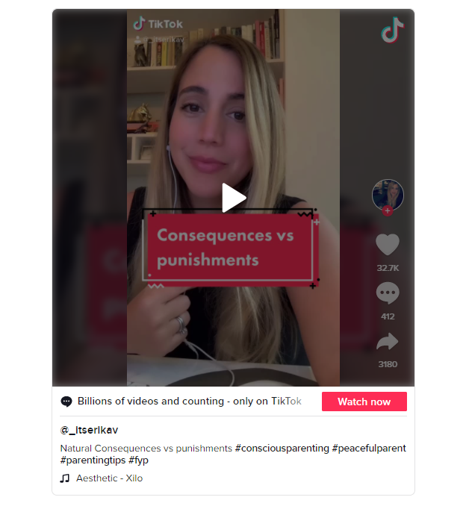

In conclusion, while both natural consequences and punishment have their benefits, natural consequences are generally a more effective and positive approach to discipline. By allowing children to experience the natural outcomes of their actions, parents can help them develop responsibility, self-reliance, and problem-solving skills. Furthermore, natural consequences can foster a stronger and more positive parent-child relationship, as children are more likely to feel respected and trusted by their parents.

<https://www.tiktok.com/@_itserikav/video/6926931411312135430>

# **#consciousparenting #peacfulparent#parentingtips#fyp**

* "Parenting with Intent: Natural Consequences vs Punishment"
* "Empowering Children through Discipline: A Comparison of Natural Consequences and Punishment"
* "The Responsible Parent's Guide to Disciplining Children: Natural Consequences vs Punishment"
* "Fostering Resilience in Children: Natural Consequences and Punishment Explained"
* "Balancing Correction and Growth: The Benefits and Drawbacks of Natural Consequences and Punishment"

